TRAC – Loading Images

https://lowesvp.archway.com
- Make sure all images are under 5 MB or they will fail. Using the “Snip” tool can help with this.
- If the item is in D status the photo will NOT load. I status and A status are accepted.
- Name JPG files EXACTLY AS THE LOWE’S SKU IS NAMED (NOTHING EXTRA) or it won’t be able to attach to the item as it’s set up in CART.
- ALL LETTERS SHOULD BE UPPER CASE IN THE NAMING CONVENTION.
- Save your file as a JPG or JPEG (JPG is the preferred, but both will work).
- the Lowe’s sku is named and with the JPG or JPEG extension, you can proceed to load them. Try loading 10 or so at a time depending on the size of the files.

Go to home screen > Loads > Load Images/PDFs
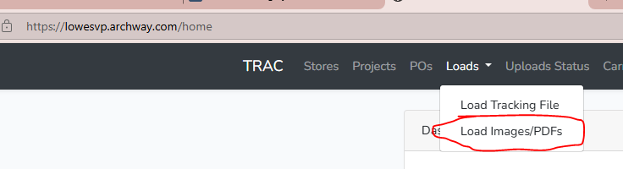
Click blue button, top left “Upload Image/PDF(s)”.
Choose your file(s) and hit “Upload”.
Within a few minutes you should be able to see your images in CART.
Data comes over once per day for Order Point and won’t be reflected next day if the photos were run after the report was run.
You can see what loaded in the “Loads” tab. Give it a few minutes and you may need to refresh to see the latest loaded items.

